AI Traffic Light Optimizer
- Introduction
Traffic congestion is one of the biggest challenges faced in modern cities. Traditional traffic lights operate on fixed timers, which often results in unnecessary waiting times, longer queues, and traffic jams. Our project, AI Traffic Light Optimizer, solves this problem by dynamically adjusting traffic light timings based on real-time vehicle density and type. By using artificial intelligence for vehicle detection and signal optimization, the system ensures smoother traffic flow, reduced waiting times, and lower fuel consumption.

Traffic lights usually change after a fixed time. If one lane is crowded and another is empty, fixed timers still cause unnecessary waiting. Our system watches the road, counts vehicles, understands which lane has more traffic, and then gives more green time to the busy lane. That makes traffic flow smoother.
Why this matters:
- People wait less at signals.
- Vehicles burn less fuel while idling.
- Emergency vehicles get through faster when system is extended.

- Team Members
- Shivam Paliwal – Team Leader & Integration
- Aryan Bhandari – Signal Logic
- Aditya Tiwari – Model Training & Dataset
- Mohd. Arham – Frontend Development
- Shivam Kumar Sharma – Vehicle Counting
- Gaurav Rawat – Signal Hardware & Circuit Design

- Problem Statement
- Current traffic lights work on fixed time intervals.
- Empty roads still face red signals while crowded roads remain blocked.
- Emergency vehicles get delayed due to inefficient signal systems.
- Long waiting times increase fuel usage and air pollution.
- Manual traffic police intervention is often required during peak hours.
- Morning peak: one direction has buses and heavy vehicles, others are empty. Fixed timers create long queues.
- Event day: sudden traffic surge near stadium — manual control is slow.
- Ambulance arrives but has to wait because lights are using fixed cycles.
Our system addresses these by adapting timings in real-time.

- Project goals and objectives
- Specific: Detect and count vehicles per lane in real-time and adjust green-time dynamically.
- Measurable: Reduce average waiting time at the intersection by ≥20% in simulation.
- Achievable: Use pre-trained YOLO model and simple optimization formula.
- Relevant: Helps city traffic flow and emergency response.
- Time-bound: Build demo and presentation-ready prototype within hackathon timeframe.

- System Architecture
The overall system follows these steps:
- Input → Traffic camera provides live video feed.
- Detection → AI model (YOLOv8) detects vehicles in each lane.
- Counting & Weighting → Each vehicle is counted and assigned a weight.
  - Bike = 1
  - Car = 3
  - Bus/Truck = 5
- Density Calculation → Weighted sum of vehicles per lane.
- Signal Optimization → Formula decides green light duration.
- Output → Traffic light timings adjusted and shown in simulation GUI.
( Camera → Detection → Counting → Optimization → Signal Output)
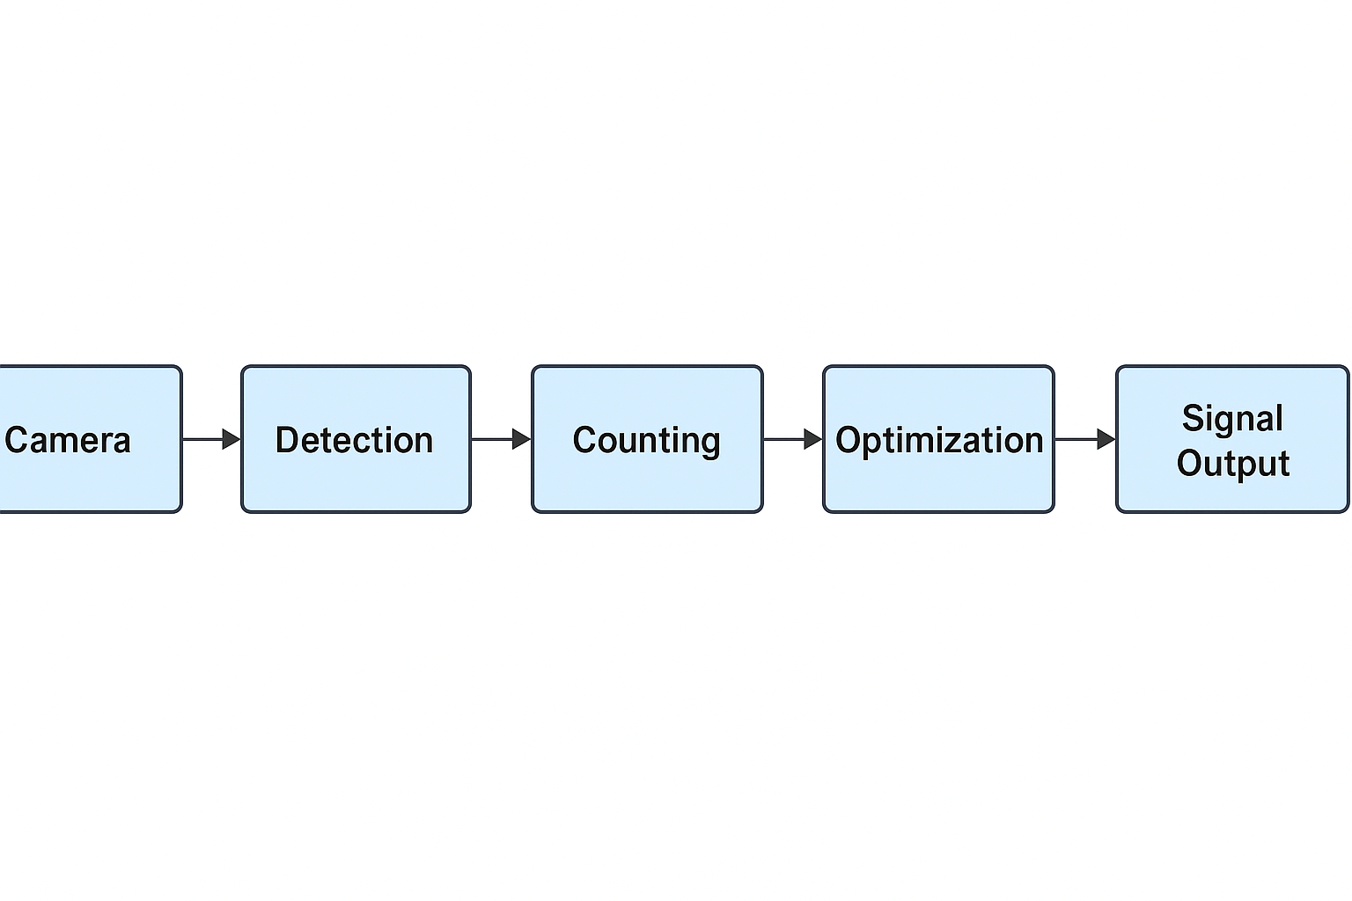

- Methodology
- Dataset: Custom dataset created from traffic images and open-source Roboflow dataset.
- Model Training: YOLOv8 trained for real-time vehicle detection.
- Counting Logic: Python script assigns weight per detected vehicle.
- Optimization Formula:

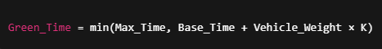
- where K = scaling factor, Base_Time = minimum green duration.
- Pseudocode for controller:

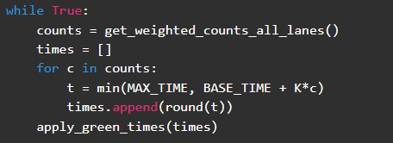

- Simulation: Tkinter/Pygame/Streamlit GUI used for live demo.
Data Flow Diagram:
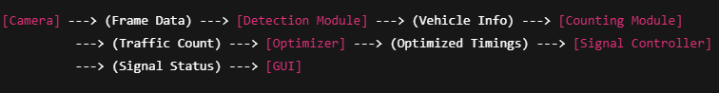

- Features

✅ Real-time AI-based vehicle detection.
✅ Weighted vehicle counting system.
✅ Dynamic green light timing.
✅ GUI simulation of traffic lights.
✅ Scalability for multiple intersections.
✅ Reduced congestion and waiting time.
- Project Structure
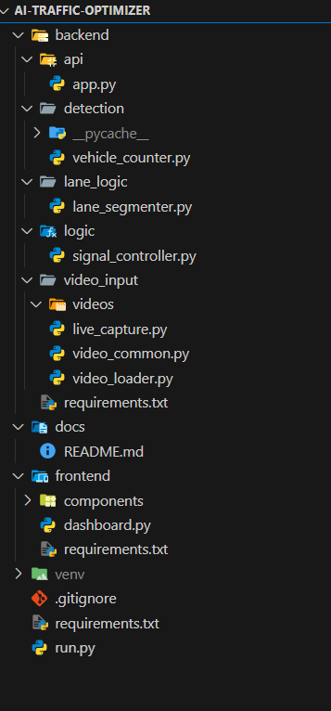

- Results
- Traffic flow improved significantly in simulation.
- Waiting time reduced by approximately 25–30%.
- Fuel wastage reduced since vehicles idle less.
- Demonstrated smoother flow during peak hours.

- Future Scope
- Emergency Vehicle Priority – Automatic green corridor for ambulances.
- IoT Integration – Sensors for accurate traffic density measurement.
- Cloud Connectivity – Centralized traffic management system.
- Scalability – Apply system to multiple junctions in a smart city.
- Data Analytics – Use traffic data for city planning and road design.

- Tools & Technologies
- Programming Language: Python
- Libraries: OpenCV, YOLOv8, Tkinter/Streamlit, NumPy, Pandas
- Dataset: Roboflow custom dataset + collected traffic images
- Platform: Google Colab (training), Local machine (testing & simulation)
- Hardware Components: Microcontroller (e.g., Arduino/NodeMCU), Relay Modules, Basic PCB Circuit
- Communication Protocols: Serial/UART for AI-to-Hardware integration

- Team Roles
- Frontend Developer → GUI design and visualization.
- Vehicle Detection Lead → AI model training & object detection.
- Signal Logic Developer → Optimization formula & signal control.
- Vehicle Counter Developer → Counting & weight assignment logic.
- Integration Engineer → Combine all modules into final system.
- Signal Hardware Engineer → Circuit design, relay control & microcontroller setup
- Documentation & Presentation → Project report, PPT, and submission material.

